NATIONAL ASSOCIATION OF STATE UTILITY
CONSUMER ADVOCATES
WATER COMMITTEE

Bios and Headshots

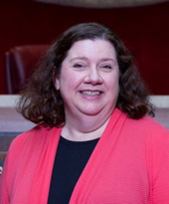
Christina Baker, PE, JD
Attorney Specialist
Arkansas Public Service Commission

Christina Baker recently announced a return to the Arkansas Public Service Commission an Attorney Specialist. In that role, she will provide legal and technical guidance on a wide range of utility issues to the Commission’s General Staff. Previously Christina was a Senior Assistant Attorney General with the Arkansas Attorney General’s Office working on public utility and environmental issues. Within that role, she acted as lead attorney of the Consumer Utilities Rate Advocacy Division and routinely provided expert witness testimony regarding positions taken by the Attorney General to protect Arkansas citizens. Prior to joining the Attorney General’s Office, she worked with the Arkansas Public Service Commission as a Staff Attorney in a similar role as she currently holds. Before her move to Arkansas in 2015, Christina worked for more than 9 years with the Office of the Public Counsel in Missouri appearing as a utility consumer advocate before the Missouri Public Service Commission. She also has over 12 years of experience as an Environmental Engineer.

Christina is licensed to practice law in the Arkansas and Missouri. She holds Professional Engineer licenses in Arkansas, Missouri, and Illinois. She received her Juris Doctorate from St. Louis University School of Law. She also holds a BS in Chemical Engineering and a Master of Laws (LLM) in Dispute Resolution.

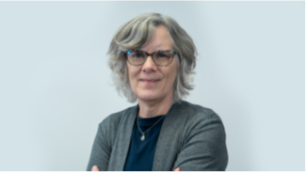
Janice Beecher
Director
Institute of Public Utilities
Michigan State University

Dr. Janice Beecher has served as Director of the Institute of Public Utilities at Michigan State University since 2002, and now brings more than 30 years of experience to the position. The Institute delivers continuing professional education and applied research to the regulatory policy community. Dr. Beecher's areas of interest include regulatory institutions, principles, and practices; infrastructure funding and financing; and the structure and governance of the water sector.

She is a frequent author, lecturer, and participant in professional forums and Editor of the journal Utilities Policy (Elsevier). She co-authored the book Risk Principles for Public Utility Regulators (MSU Press). Dr. Beecher has served on the U.S. EPA’s Environmental Finance Advisory Board and Michigan's 21st Century Infrastructure Commission and chaired the water rates subcommittee of the Flint Water Interagency Coordinating Committee. She has also advised the federal, state, and local governments on water policy, pricing, and affordability. She held positions at The Ohio State and Indiana Universities and the Illinois Commerce Commission. She is a faculty member in MSU’s Department of Political Science (Adjunct, Economics) and holds a Ph.D. in Political Science from Northwestern University.
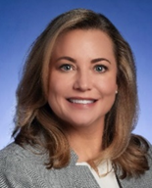
Kelly Cashman-Grams

General Counsel

Tennessee Public Utility Commission

As General Counsel of the Tennessee Public Utility Commission, Kelly Cashman-Grams oversees the Commission’s Legal Division, which includes 5 staff members and an allocated budget of approximately one million dollars. She is responsible for providing legal counsel to the agency’s seven appointed part-time Commissioners, the Executive Director, Division Directors, and agency staff, on legal, regulatory, legislative, and policy matters of importance to the agency and its regulation of investor-owned public utilities. She leads Division attorneys and legal staff in the resolution of unique and challenging issues that arise before the agency, and ensures efficient workflow and high-quality results in, among other functions, the initiation of new dockets, dockets and records management, preparation and review of recommendations, timely drafting and issuance of final agency orders, contracts, and procurement.

With a standing delegation of authority from the Commissioners, Kelly presides as or designates another to act as hearing officer on rulemaking and contested case proceedings involving complex and technical subject matter to ensure that all appropriate procedural safeguards, statutes, and regulations, are observed in rendering decisions on the merits and preparing cases for hearing before the assigned panel of Commissioners. She represents and oversees agency attorneys in litigation before the agency, state trial courts and courts of appeal, and state and federal agencies, and in various hearings before the Tennessee General Assembly.

Kelly holds a bachelor’s degree in English Literature, graduating cum laude with departmental honors, from Oakland University in Rochester, Michigan. Licensed to practice law since 1998, Kelly earned a juris doctorate from Detroit-Mercy University School of Law in Detroit, Michigan. She was awarded the law school’s Presidential Grant Scholarship and Academic Excellence Award in Contracts Law. During law school, Kelly interned as a law clerk to the Honorable James R. Chylinski of the 3rd Judicial Circuit Court in Detroit, Michigan. She and her family have lived in the Nashville, Tennessee, area for more than twenty years.

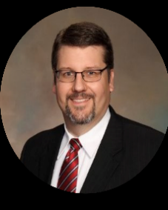
Aaron J. Conklin
Senior Counsel

Tennessee Public Utility Commission

Aaron J. Conklin in Senior Counsel for the Tennessee Public Utility Commission. Prior to joining the Public Utility Commission in December 2016, Aaron has practiced law in both the private and governmental sectors. He has been a general practice private attorney, handling civil, criminal, family law, bankruptcy, and estate planning matters. He also served as a Senior Associate for an insurance defense firm practicing in auto and premises liability and contract matters. He has litigated in both trial and appellate courts throughout the State of Tennessee. For ten years, Aaron served as Assistant General Counsel for the Administrative Office of the Courts, representing the judicial branch of the government for the State of Tennessee. Aaron has been a frequent speaker on legal issues, such as accessible courtrooms and court programs, municipal courts, judicial ethics, and legislative updates.

Since joining the TPUC, Aaron has served as an advisory counsel to the Commission and as a hearing officer in designated matters. He also serves as the attorney advisor to investigative staff for the Underground Utility Damage Enforcement Board, as well as the attorney handling all enforcement matters for the Board.
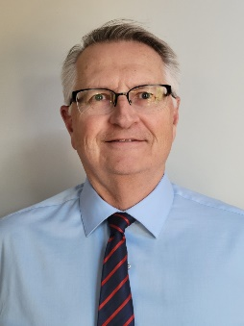
David N. Dittemore, CPA
Consultant
Blue River Consulting LLC

Dave Dittemore is our presenter. He began his regulatory career as an auditor with the Kansas Corporation Commission Staff where he eventually became Chief Auditor and then Director of Utilities for the KCC Staff. While at the KCC he testified on a number of complex dockets, including rate cases as well as several merger applications. He also was responsible for training and professional development of staff members. In his role he also provided counsel to Commissioners’, assisted in the drafting of Commission orders, and assisted legal staff in hearing preparation. For a number of years, he had a leadership role in the negotiations of regulatory matters between Staff, utilities and other intervenors as well as representing the Commission staff before the Kansas legislature.

He later joined an investor-owned utility where he was Director of Regulatory Affairs for one of its divisions where he was responsible for the overall preparation of utility revenue requirements for one of the utilities three divisions for approximately 11 years. In this role he frequently interacted with utility executives and was the primary company liaison with both the Commission staff as well as the Consumer Advocate. In 2017 he joined the Tennessee Attorney General’s office as a Financial Analyst, providing testimony in the majority of the casework of the Consumer Advocate’s office during his tenure. He was also Vice-Chair of the NASUCA Accounting committee and was an active participant in the NASUCA gas and water committees. In 2021 he began a solo consulting practice representing Consumer Advocates in various states.

Dave holds a degree in Accounting from the University of Central Missouri and is a CPA

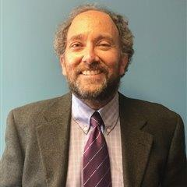
Ed Kaufman
Utility Accounting and Finance Division
Virginia State Corporation Commission

Ed Kaufman works in the Utility Accounting and Finance division for the Virginia State Corporation Commission ("SCC"). He has worked for the SCC as a Principal Utility Specialist for three years. Ed has worked on various accounting, finance, and policy issues during his three years at the SCC.

Prior to joining the SCC, Ed worked for the Indiana Office of Utility Consumer Counselor ("OUCC") from October of 1990 through April 2019). Ed joined the OUCC as an analyst in the Economics and Finance Division. After the OUCC reorganized he joined the Water-Wastewater Division. During his tenure he was promoted to Chief Technical Analyst and then to Assistant Director of the Water-Wastewater division. Ed’s area of expertise is in utility finance and regulatory policy. He is particularly knowledgeable in cost of equity and typically provided cost of equity testimony in cases outside of his division.

Ed holds both a B.S. in Economics-Finance and an A.S. in Accountancy from Bentley College in Waltham MA. He earned a MS in Management with options in Finance and Strategic Management from Purdue University.

Ed serves on SURFA's board of directors and holds a CRRA designation.
Ed is on the Board of Directors at Or Ami Congregation and serves as Treasurer.

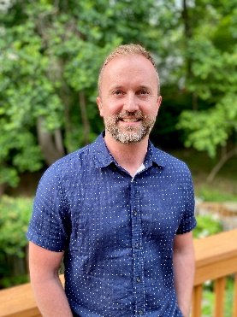
Matt King
Office of Groundwater and Drinking Water
U.S. Environmental Protection Agency

Matt joined EPA in 2009 and currently serves as a member of the Drinking Water State Revolving Fund team in the Office of Groundwater and Drinking Water. His work is focused on collaborating with federal and state partners to solve infrastructure challenges and protect public health and water quality. Prior to joining the Drinking Water State Revolving Fund Matt worked in its sister program, the Clean Water State Revolving Fund. He also spent time in EPA’s Water Permits Division where he worked to implement stormwater permitting programs and advance green infrastructure implementation. Matt holds a Bachelor of Arts in English from the University of Illinois, a Master of Public Affairs in Environmental Policy and Natural Resource Management from Indiana University and is currently pursuing a Master of Science in Environmental Science from the University of Illinois.

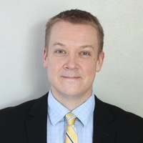
Geoff Marke, PhD
Chief Economist
Missouri Office of the Public Counsel

Geoff Marke, PhD, is the Chief Economist for the Missouri Office of the Public Counsel (“OPC”) within the Missouri Department of Commerce and Insurance. In this position, he manages a technical staff that advocates for Missouri ratepayers in utility regulatory and legislative filings involving electric, gas and water/sewer companies. He has provided expert testimony on a variety of issues including, but not limited to: Demand-Side Management, Rate Design, Performance Based Regulation, Integrated Resource Planning and Economic Development. Geoff has been a frequent speaker at NARUC, NASUCA and Michigan State’s Institute of Public Utilities conferences/seminars. He has also participated in US AID utility seminars with 13 Baltic Countries (North Macedonia, Cyber Security) and with the country of Indonesia (Tariffs and Cost of Service Regulation). He is also the reigning champion of his Fantasy Football League.

Susan E. McClure, Esq.
Managing Attorney - Water/Wastewater
New Jersey Division of Rate Counsel

Susan E. McClure, Esq., is the Managing Attorney for the Water/Wastewater specialty group within the Division of Rate Counsel. She has been with the Division of Rate Counsel since August of 1997 and is responsible for providing expertise in all aspects of utility law to ensure water and wastewater utility consumers receive reasonable rates and the best quality of service. Susan oversees attorneys and support staff in the preparation of pleadings, expert testimony and exhibits in connection with the regulatory oversight of water and wastewater companies in New Jersey.
Susan from 1995 to 1997 was employed by the The Rothfelder Law Offices. Prior to 1995, Susan was employed by McManimon and Scotland. Susan worked on public utility cases for both firms. She was responsible for preparing briefs, pleadings and memoranda for clients ranging from cogeneration to cellular companies, county utility authorities to municipalities and others, on issues of solid waste regulatory law, municipal franchise law, contract law and water public utility law.

Susan has a Bachelor of Arts Degree in Psychology from Livingston College-Rutgers University and a Juris Doctorate from Seton Hall School of Law, Newark.

Kyle Onda
Associate Director
Internet of Water
Lincoln Institute’s Center for Geospatial Solutions

Kyle is the associate director of the Internet of Water initiative at the Lincoln Institute’s Center for Geospatial Solutions. Kyle has training and experience as an environmental engineer, urban planner, environmental public health professional, geospatial technologist, and social scientist.

He has been lucky to pursue an academic and professional career addressing diverse and pressing policy questions about links between water, the natural and built environments, and political economy. He has sampled surface waters for state regulatory agencies; managed survey fieldwork in low- and middle-income countries regarding rural and urban drinking water systems and their customers; consulted on urbanization research projects associated with the World Bank and Asian Development Bank; provided research design and statistical analyses for studies of U.S. coastal hazards policies; and developed time series models to analyze water meter and billing data in the private sector.

Kyle is a PhD candidate (ABD) in city and regional planning at UNC–Chapel Hill and also holds master’s degrees in city and regional planning and public health from UNC and a B.S. in environmental engineering from Stanford.

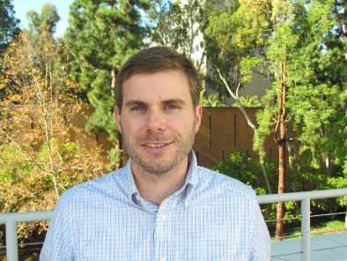
Gregory Pierce
Co-Director
Luskin Center for Innovation

Greg Pierce (he/him) is the co-director of the Luskin Center for Innovation and the director of the Human Right to Water Solutions Lab within the center. He is also the co-director of the UCLA Water Resources Group within the Institute of the Environment and Sustainability and serves as an adjunct associate professor in the department of urban planning. Since joining the Luskin Center in 2015, he has been instrumental in guiding the Center's leadership to inform Human Right to Water policy in California, as well as across the United States. He has authored 40+ peer-reviewed journal articles and numerous major research reports, including many with California state and local agencies. His broader research interests lie at the intersection of public finance, infrastructure planning and environmental justice. Greg holds a PhD in Urban Planning from UCLA.

Richard Rauschmeier
Program Manager – Water Branch
Public Advocates Office at the
California Public Utilities Commission

Richard oversees the production of testimony, reports, and recommendations representing the public interest in water proceedings at the California Public Utilities Commission, where he has served for the last fifteen years. In addition to managing a staff of thirty engineers, accountants, and analysts, he has testified as an expert witness on most facets of rate-of-return regulation, including such specialty topics as cost-of-capital, mergers and acquisitions, conservation rate design, and utility affiliate transactions. He has been licensed as both a Grade 3 Water Treatment and Distribution Operator in California and frequently volunteers his services at small mutual water systems that are not subject to economic regulation.

He received his Master of Science in Financial Management from the Krannert School of Business at Purdue University and his bachelor’s degree in Environmental Science from the Johns Hopkins University.

Ralph Smith
Senior Regulatory Consultant
Larkin Associates PLLC

Ralph C. Smith, Esq., CPA, CRRA, and CFP™ professional, is a senior regulatory consultant with Larkin. He has over 43 years of experience as a regulatory consultant and has supervised numerous projects. He has provided testimony in numerous regulatory cases involving electric, gas, telephone and water and sewer utilities. He functions as project manager on consulting projects involving utility regulation, regulatory policy and ratemaking and utility management.

He received a Bachelor of Science in Administration in Accounting, with distinction, University of Michigan, Dearborn, 1979; a Master of Science in Taxation, Walsh College, Michigan, 1981. His Master's thesis dealt with investment tax credit and property tax on various assets. He also graduated, cum laude, with a Juris Doctor from Wayne State University Law School, Detroit, Michigan, 1986, and received an American Jurisprudence Award for academic excellence. His involvement in public utility regulation has included project management and in-depth analyses of numerous issues involving telephone, electric, gas, and water and sewer utilities.

Over the past 43 years, Mr. Smith has performed work in the field of utility regulation on behalf of industry, public service commission staffs, state attorney generals, municipalities, and consumer groups concerning regulatory matters before regulatory agencies in Alabama, Alaska, Arizona, Arkansas, California, Connecticut, Delaware, Florida, Georgia, Hawaii, Illinois, Indiana, Kansas, Kentucky, Louisiana, Maine, Maryland, Michigan, Minnesota, Mississippi, Missouri, Montana, New Jersey, New Mexico, New York, Nevada, North Carolina, North Dakota, Ohio, Pennsylvania, Puerto Rico, Rhode Island, South Carolina, South Dakota, Tennessee, Texas, Utah, Vermont, Virginia, Washington, Washington DC, West Virginia, Canada, Federal Energy Regulatory Commission and various state and federal courts of law. He has presented expert testimony in regulatory hearings on behalf of utility commission staffs and intervenors on several occasions of Poyner Spruill LLP from June 2009 to July 2013 and Hunton & Williams LLP from August 2003 to June 2009. He served a two-year term on the North Carolina Environmental Management Commission from July 2011 through June 2013.

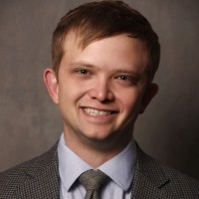
Grady Strout
Director of Engineering
Tennessee American Water Company

Grady Stout is director of engineering of Tennessee American Water, the largest investor-owned water utility in the state, providing high-quality and reliable water services to nearly 400,000 people. In this role, Mr. Stout’s responsibilities include oversight of the Engineering Department team, managing various projects and a multi-million-dollar capital budget. He is also responsible for regulatory compliance and business development.

Mr. Stout joined Tennessee American Water in 2013 and earned his Professional Engineer license in 2015. Previously he served as engineering manager and was accountable for the overall management, engineering design, bidding, and construction management on projects relating to various aspects of the business. He has also spent time in the operations side of the business where he served as interim vice president in 2020 and led the company’s COVID-19 response team.

Mr. Stout graduated from Tennessee Technological University in 2011 with a B.S. in Civil Engineering. His involvement from an early age in his family’s construction business in Mountain City, Tennessee, brings strong utility experience to the team. He is an active member in ASCE, AWWA, and served as the 2020 President of the Chattanooga Engineers Club. He was awarded the General Robert Neyland Young Engineer of the Year by Chattanooga E-Week in 2022.

Mr. Stout resides in Soddy Daisy with his wife, Evelyn, and three young children, Roland, Anna, and Reed. He enjoys golfing, fishing, and CrossFit. Tapping into his Appalachian roots, he enjoys a wide range of music and plays the guitar and banjo.

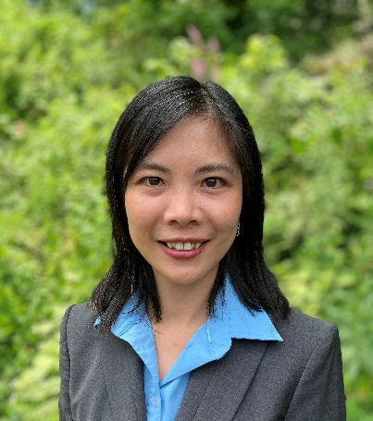
Ying Tan, MSc
Physical Scientist
Office of Ground Water and Drinking Water
Environmental Protection Agency

Ying Tan joined the Environmental Protection Agency (EPA) in 2020 with the determination of protecting public health and reducing lead in the nation’s drinking water at school and childcare facilities. As part of EPA’s 3Ts (Training, Testing, and Taking Action) team, she focuses on protecting children’s health by reducing lead from drinking water along with EPA’s federal and non-federal partners. She also oversees two grant programs with over $100 million in funding to reduce lead in drinking water.

Before joining the EPA, as an assistant program manager at the Water Quality & Technology Department for DC Water, Ying oversaw the lead compliance and water quality monitoring programs as well as provided provisions to the lead service line monitoring and replacement projects.

Ying has over twelve years of experience on water quality and lead reduction projects in drinking water. She had her master’s degree in Civil & Environmental Engineering from the University of Minnesota with a focus on lead corrosion control in drinking water and holds a bachelor’s degree in Chemical Engineering from the University of Illinois Urbana-Champaign.

Xue Zhang
Research Associate, CRP and Global Development Departments, Cornell University.
Xue Zhang is a Research Associate in the Department of City and Regional Planning and the Department of Global Development at Cornell University. She is interested in regional development, equity, community development policy, and public health. Her current research focuses on local government actions in building healthy communities. More recently, her research focus on local governments’ response to equitable water access in the U.S.

